**Exercise 4: Arrange-Act-Assert (AAA) Pattern, Test Fixtures, Setup and Teardown Methods in JUnit**

**Scenario:** You need to organize your tests using the Arrange-Act-Assert (AAA) pattern and use setup and teardown methods.

**STRUCTURE:**

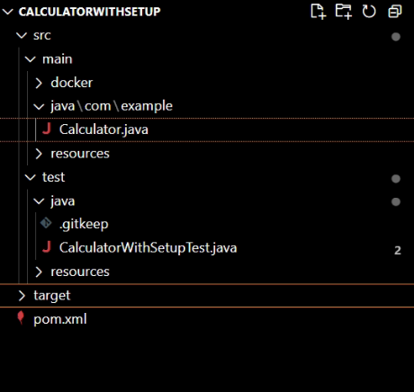

**CODE:**

package com.example;

import org.junit.Before;

import org.junit.After;

import org.junit.Test;

import static org.junit.Assert.*;

public class CalculatorWithSetupTest {

private Calculator calculator;

// This method runs BEFORE each test

@Before

public void setUp() {

calculator = new Calculator();

System.out.println("Setup done.");

}

// This method runs AFTER each test

@After

public void tearDown() {

calculator = null;

System.out.println("Teardown done.");

}

@Test

public void testAdd() {

// Arrange

int a = 2;

int b = 3;

// Act

int result = calculator.add(a, b);

// Assert

assertEquals(5, result);

}

@Test

public void testAddNegativeNumbers() {

// Arrange

int a = -5;

int b = -10;

// Act

int result = calculator.add(a, b);

// Assert

assertEquals(-15, result);

}

}

**OUTPUT:**

